Agricultural Methane & CO2 Emission

Your Name

In this research, 4 countries chose to interrelation CO2 Emissions from manufacturing industries and construction. The carbon dioxide gasses release due to the combustion of fossil fuel, natural gas, and oil. CO2 is dangerous to a person's health like headaches, dizziness, difficulty breathing, increase heart rate, blood pressure, coma, and asphyxia. Agricultural methane emission increases due to the rising food needs. If it increases this way then it's an alarming situation for us because it is 80% more than carbon dioxide.

This table shows the CO2 emission from 1990-2015 in France, Portugal, Japan, and Germany.

|  |  |  |  |  |
| --- | --- | --- | --- | --- |
| **country** | **France** | **Portugal** | **Germany** | **Japan** |
| **1990** | 6.117208 | 4.113904 | 12.02661 | 8.831776 |
| **1995** | 5.915834 | 5.055766 | 10.70863 | 9.332839 |
| **2000** | 6.125508 | 5.992285 | 10.09932 | 9.323416 |
| **2005** | 6.025069 | 6.233261 | 9.729424 | 9.491989 |
| **2010** | 5.348198 | 4.817887 | 9.4534 | 9.030062 |
| **2015** | 4.677807 | 4.81267 | 9.087291 | 9.276629 |

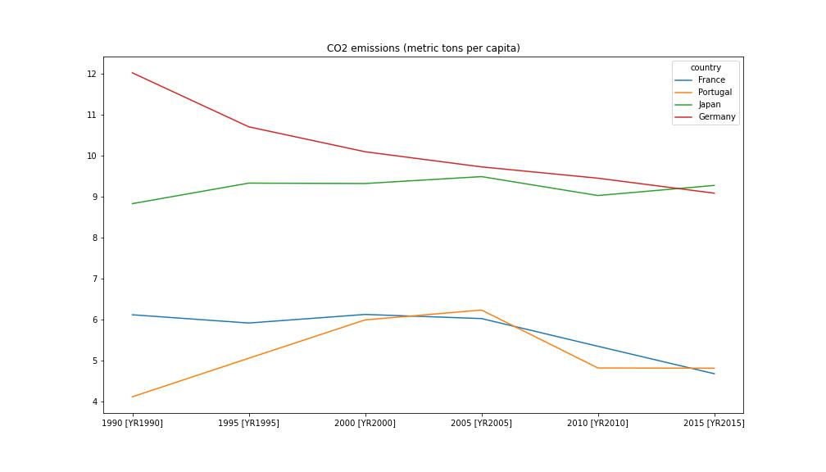**Table: CO2 emission 1990-2020**

CO2 emission Line graph

The CO2 emission (metric tons per capita) in the line graph shows that it decreases year by year but the use of CO2 gasses is too high. So it needs to decrease more over time. Mostly these gases spread disease in the world.

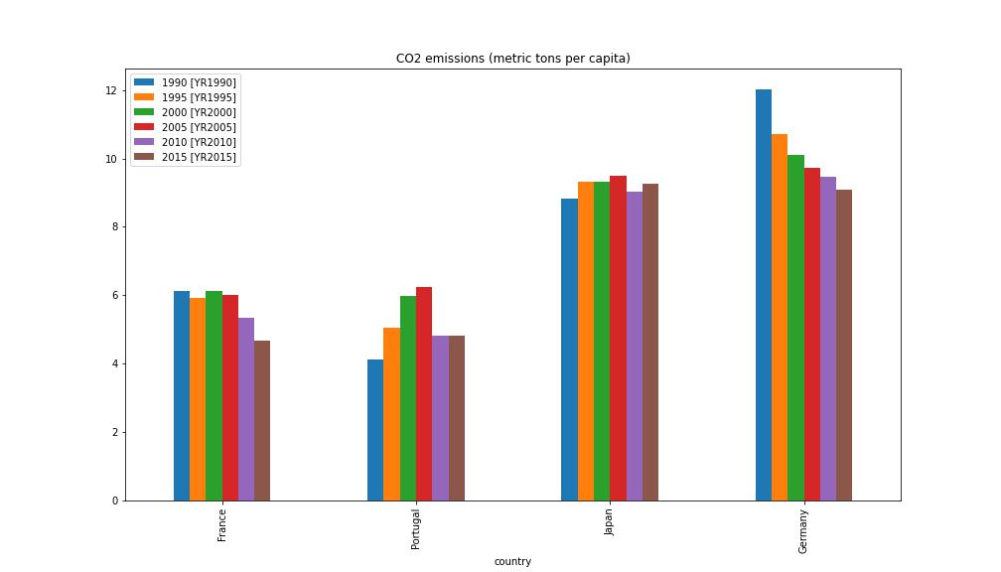The bar graph shows that Germany used CO2 gases high as compared to the others. The 2nd largest country that uses CO2 emissions is Japan. The heatmap shows that Germany and Japan use gases more as compared to France and Portugal because of Japan more industrial country.

CO2 Emission (metric tons per capita) Bar Graph

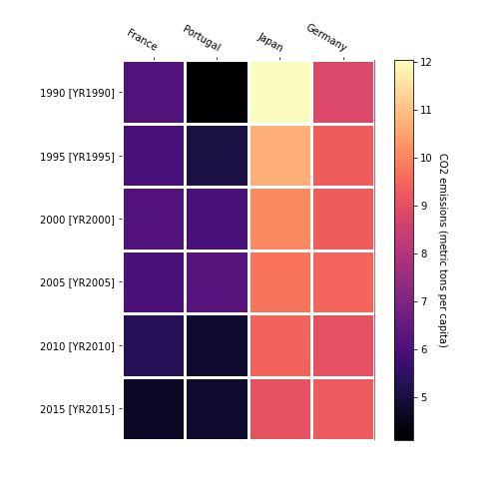

CO2 emission Heatmap graph

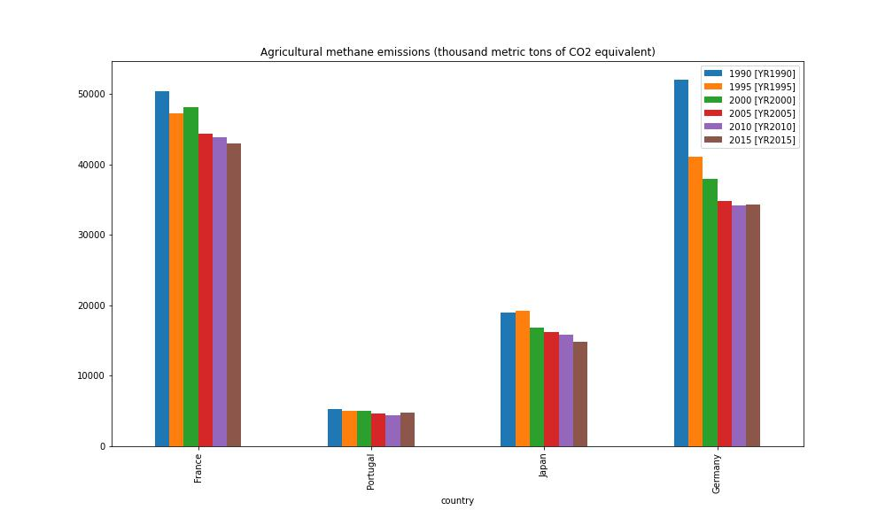This table shows the Agricultural methane emissions (thousand metric tons of CO2 equivalent) from 1990-2015 in France, Portugal, Germany, and the Japan.

|  |  |  |  |  |
| --- | --- | --- | --- | --- |
| **country** | **France** | **Portugal** | **Germany** | **Japan** |
| **1990** | 50390 | 5260 | 52060 | 19000 |
| **1995** | 47310 | 4980 | 41150 | 19240 |
| **2000** | 48120 | 4980 | 37960 | 16900 |
| **2005** | 44430 | 4660 | 34830 | 16220 |
| **2010** | 43900 | 4450 | 34200 | 15800 |
| **2015** | 43010 | 4750 | 34260 | 14770 |

**Table: Agricultural methane Emission 1990-2015**

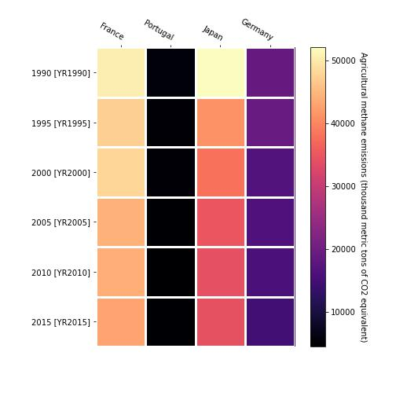

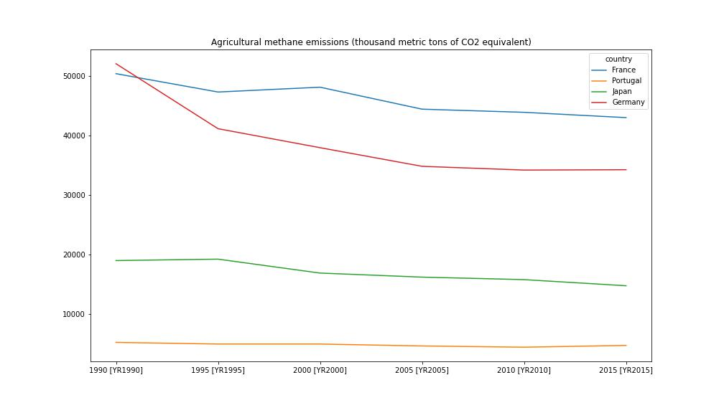 Nowadays the increasing population increases the need for food. So, the agricultural cropland has increased to fulfill the food need but it has also emitted methane gases that are more powerful than CO2 gas. Paddy rice cultivations emit most of the methane gas. The line chart shows that France county emits methane gases more than other countries. Portugal country emits fewer methane gases.

Agricultural methane emissions (thousand metric tons of CO2 equivalent) Line graph

Agricultural methane emissions (thousand metric tons of CO2 equivalent) Bar Graph

The bar graph shows that agricultural methane emissions from a different country decreased. Portugal and Japan country emit fewer methane gases as compared to others.

Agricultural methane emissions (thousand metric tons of CO2 equivalent) Heatmap Graph